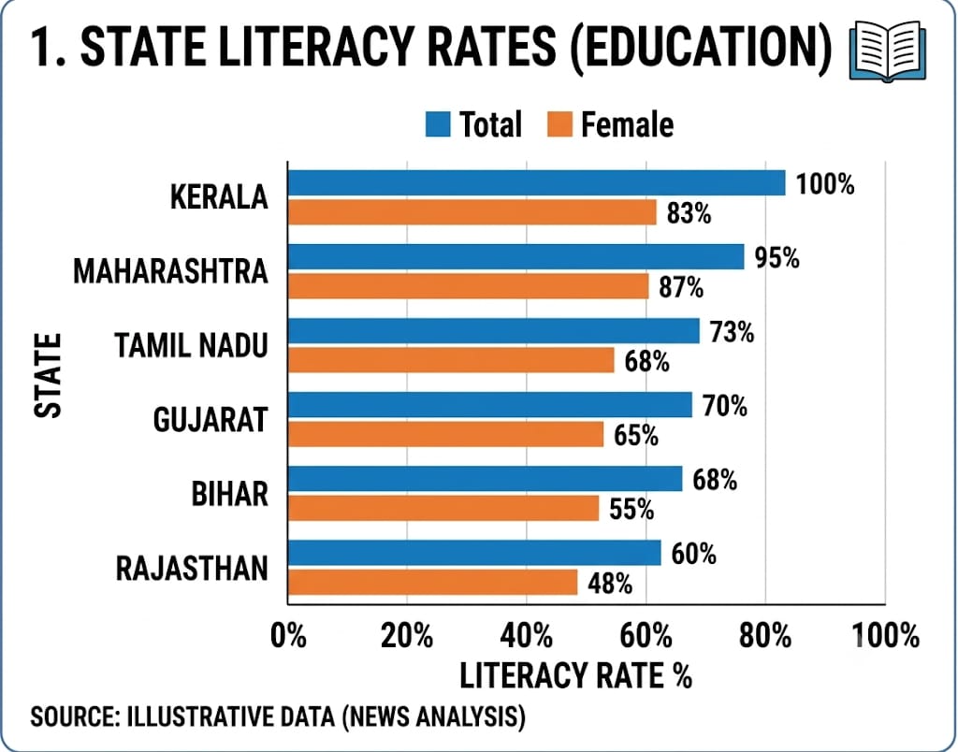

Bar Chart: Good because contrasting blue and orange colors make comparisons between categories clear and visually appealing.

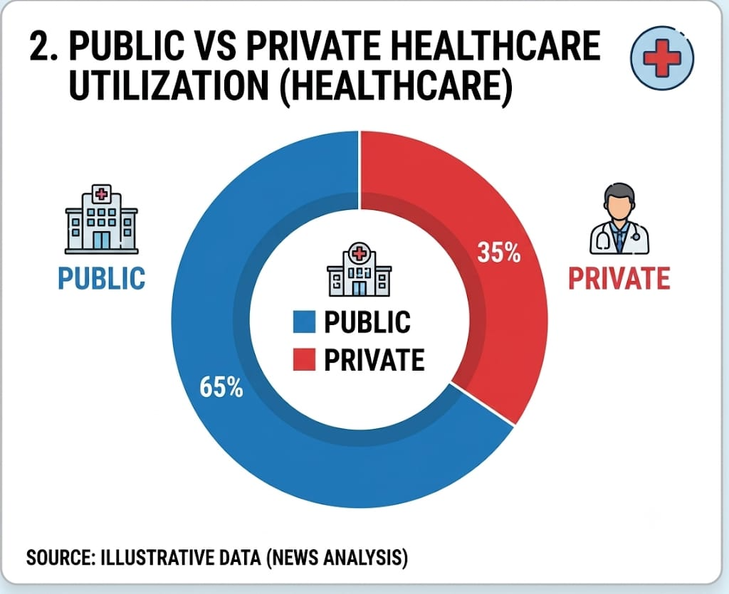

Doughnut Chart: Good because the distinct blue and red colors clearly differentiate public and private healthcare shares.

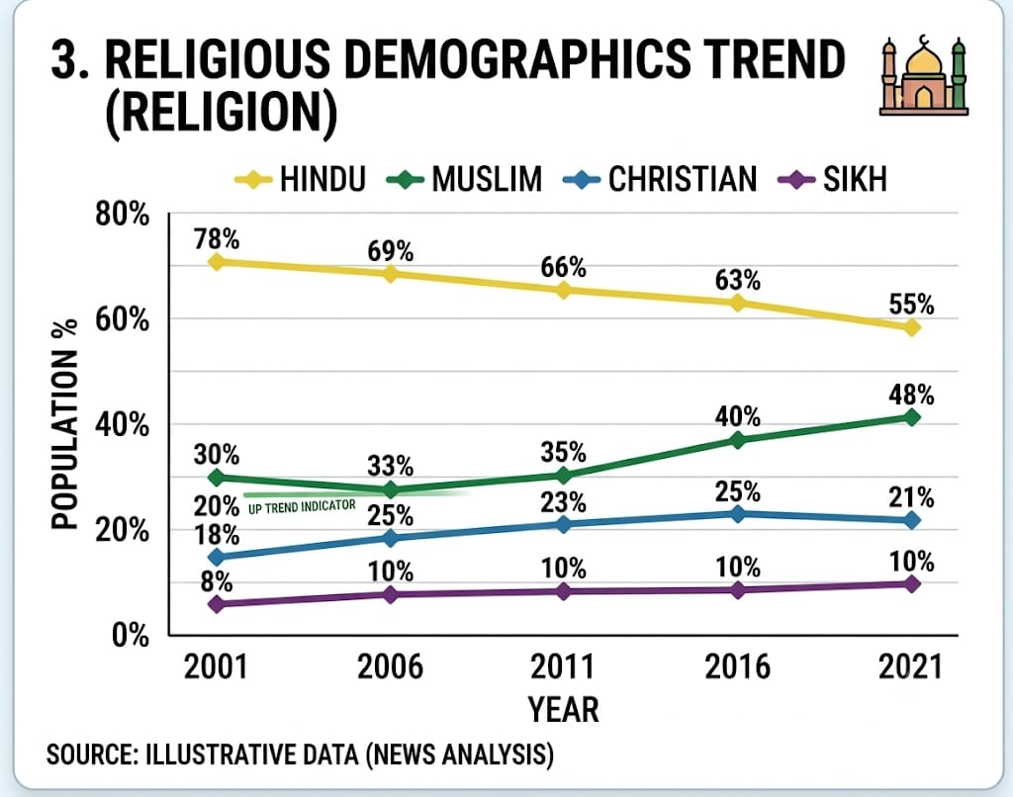
Line Chart: Good because different colored lines help distinguish multiple trends and improve readability.

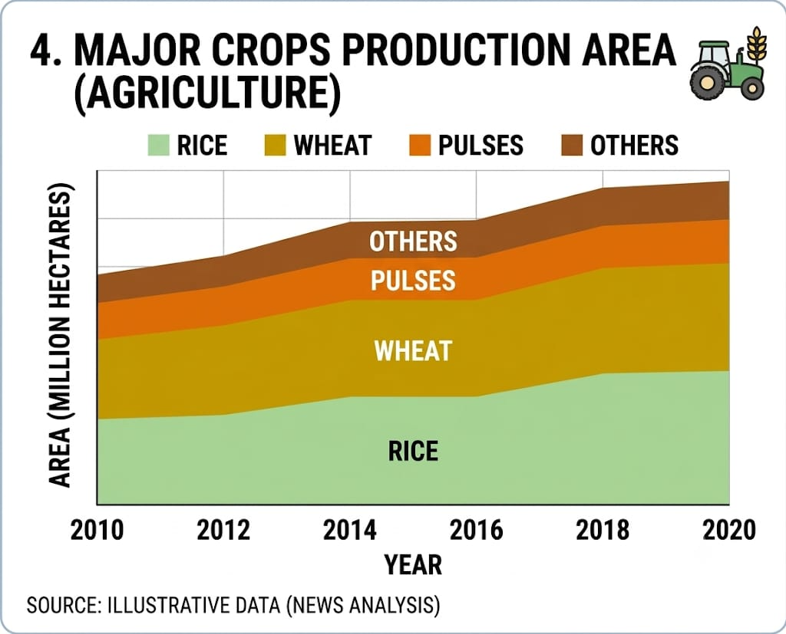
Stacked Area Chart: Good because color layering effectively shows the contribution of each crop while maintaining overall trends.

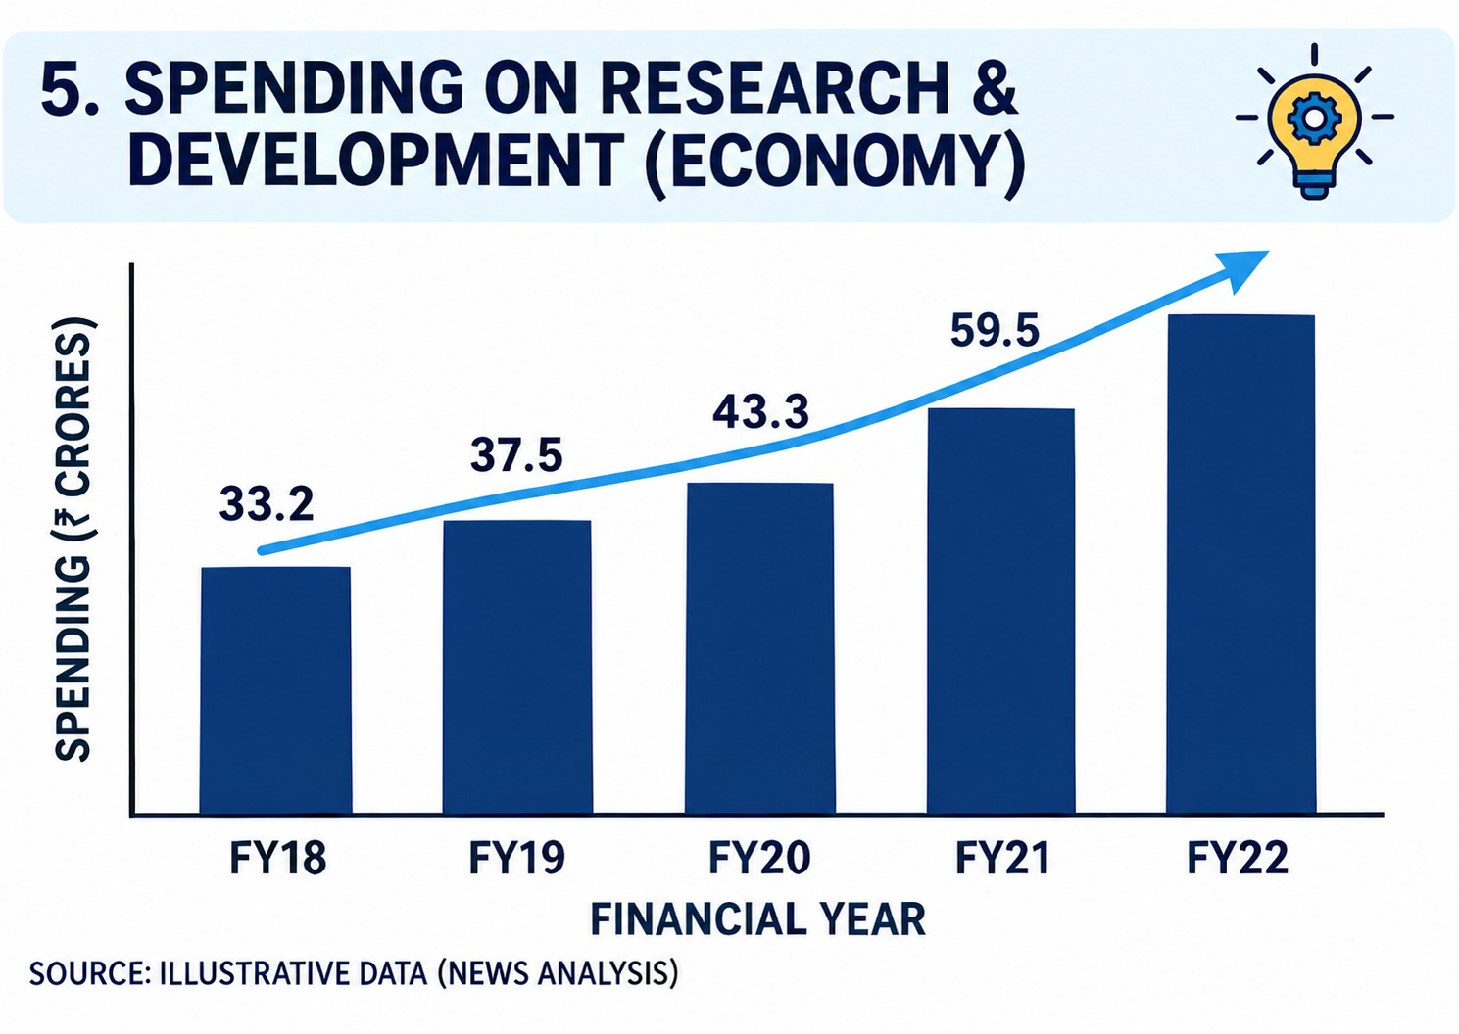

Column Chart: Good because the consistent dark blue bars emphasize growth and create a clean, professional appearance.

